UNITED STATES
SECURITIES AND EXCHANGE COMMISSION
WASHINGTON, D.C. 20549

FORM 8-K

CURRENT REPORT
Pursuant to Section 13 or 15(d) of the Securities Exchange Act of 1934
Date of Report (Date of earliest event reported): August 13, 2026


Aveanna Healthcare Holdings Inc.
(Exact name of Registrant as Specified in Its Charter)

Delaware |  |  | 001-40362 | 81-4717209
(State or Other Jurisdiction  of Incorporation) |  |  | (Commission File Number) | (IRS Employer  Identification No.)
400 Interstate North Parkway SE
Atlanta, Georgia |  |  |  | 30339
(Address of Principal Executive Offices) |  |  |  | (Zip Code)

Registrant’s Telephone Number, Including Area Code: 770 441-1580

Check the appropriate box below if the Form 8-K filing is intended to simultaneously satisfy the filing obligation of the registrant under any of the following provisions:
☐Written communications pursuant to Rule 425 under the Securities Act (17 CFR 230.425)
☐Soliciting material pursuant to Rule 14a-12 under the Exchange Act (17 CFR 240.14a-12)
☐Pre-commencement communications pursuant to Rule 14d-2(b) under the Exchange Act (17 CFR 240.14d-2(b))
☐Pre-commencement communications pursuant to Rule 13e-4(c) under the Exchange Act (17 CFR 240.13e-4(c))
Securities registered pursuant to Section 12(b) of the Act:
Title of each class |  | Trading  Symbol(s) |  | Name of each exchange on which registered
Common Stock, par value $0.01 per share |  | AVAH |  | The Nasdaq Stock Market LLC
Indicate by check mark whether the registrant is an emerging growth company as defined in Rule 405 of the Securities Act of 1933 (§ 230.405 of this chapter) or Rule 12b-2 of the Securities Exchange Act of 1934 (§ 240.12b-2 of this chapter).
Emerging growth company ☐
If an emerging growth company, indicate by check mark if the registrant has elected not to use the extended transition period for complying with any new or revised financial accounting standards provided pursuant to Section 13(a) of the Exchange Act. ☐

Item 7.01 Regulation FD Disclosure.
On August 13, 2026, Aveanna Healthcare Holdings Inc. (the "Company", "we", "us", or "our") made available a financial presentation to investors. A copy of the presentation is attached hereto as Exhibit 99.1 and incorporated by reference in this Item 7.01. A copy of the presentation is also available on our website at ir.aveanna.com.

Use of our Website and Social Media to Distribute Material Company Information

We use our website as a channel of distribution for important Company information. We routinely post on our website important information, including press releases, investor presentations and financial information, which may be accessed by clicking on the “Investors” section of www.aveanna.com. We also use our website to expedite public access to time-critical information regarding our Company in advance of or in lieu of distributing a press release or a filing with the SEC disclosing the same information. Therefore, investors should look to the “Investors” section of our website for important and time-critical information. Visitors to our website can also register to receive automatic e-mail and other notifications alerting them when certain new information is made available on our website. Information contained on, or accessible through, our website is not a part of and is not incorporated by reference in this Current Report on Form 8-K.

The information contained in this Item 7.01, including in Exhibit 99.1 attached hereto, is “furnished” and not “filed” for purposes of Section 18 of the Exchange Act or otherwise subject to the liabilities of that section. Such information shall not be incorporated by reference in another filing under the Exchange Act or the Securities Act, except to the extent such other filing specifically incorporates such information by reference.

Item 9.01 Financial Statements and Exhibits.
(d) Exhibits.

Exhibit Number |  | Description
99.1 |  | Aveanna Investor Presentation - August 2026
104 |  | Cover Page Interactive Data File (embedded within the Inline XBRL document)

SIGNATURES
Pursuant to the requirements of the Securities Exchange Act of 1934, the registrant has duly caused this report to be signed on its behalf by the undersigned thereunto duly authorized.
 |  |  | AVEANNA HEALTHCARE HOLDINGS INC.
Date: | August 13, 2026 | By: | /s/ Matthew Buckhalter
Matthew Buckhalter
Chief Financial Officer
(Principal Financial Officer)


Investor Presentation August 2026

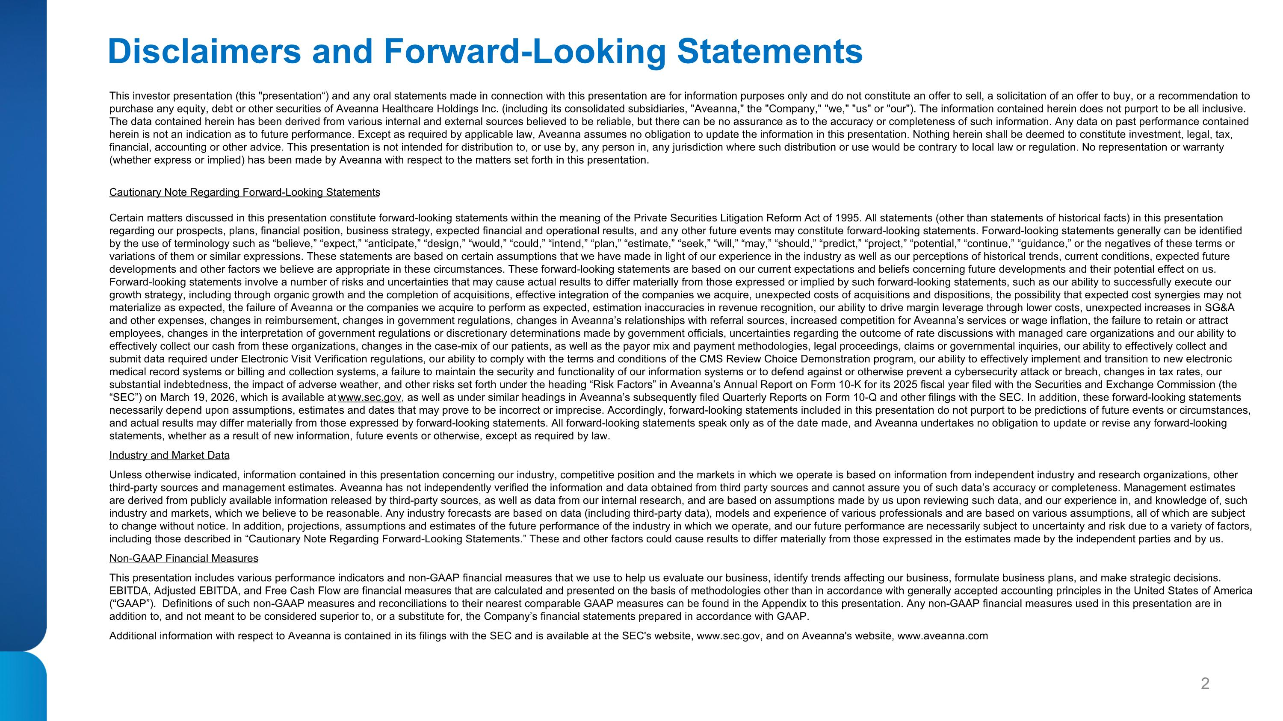
Disclaimers and Forward-Looking Statements This investor presentation (this "presentation“) and any oral statements made in connection with this presentation are for information purposes only and do not constitute an offer to sell, a solicitation of an offer to buy, or a recommendation to purchase any equity, debt or other securities of Aveanna Healthcare Holdings Inc. (including its consolidated subsidiaries, "Aveanna," the "Company," "we," "us" or "our"). The information contained herein does not purport to be all inclusive. The data contained herein has been derived from various internal and external sources believed to be reliable, but there can be no assurance as to the accuracy or completeness of such information. Any data on past performance contained herein is not an indication as to future performance. Except as required by applicable law, Aveanna assumes no obligation to update the information in this presentation. Nothing herein shall be deemed to constitute investment, legal, tax, financial, accounting or other advice. This presentation is not intended for distribution to, or use by, any person in, any jurisdiction where such distribution or use would be contrary to local law or regulation. No representation or warranty (whether express or implied) has been made by Aveanna with respect to the matters set forth in this presentation. Cautionary Note Regarding Forward-Looking Statements Certain matters discussed in this presentation constitute forward-looking statements within the meaning of the Private Securities Litigation Reform Act of 1995. All statements (other than statements of historical facts) in this presentation regarding our prospects, plans, financial position, business strategy, expected financial and operational results, and any other future events may constitute forward-looking statements. Forward-looking statements generally can be identified by the use of terminology such as “believe,” “expect,” “anticipate,” “design,” “would,” “could,” “intend,” “plan,” “estimate,” “seek,” “will,” “may,” “should,” “predict,” “project,” “potential,” “continue,” “guidance,” or the negatives of these terms or variations of them or similar expressions. These statements are based on certain assumptions that we have made in light of our experience in the industry as well as our perceptions of historical trends, current conditions, expected future developments and other factors we believe are appropriate in these circumstances. These forward-looking statements are based on our current expectations and beliefs concerning future developments and their potential effect on us. Forward-looking statements involve a number of risks and uncertainties that may cause actual results to differ materially from those expressed or implied by such forward-looking statements, such as our ability to successfully execute our growth strategy, including through organic growth and the completion of acquisitions, effective integration of the companies we acquire, unexpected costs of acquisitions and dispositions, the possibility that expected cost synergies may not materialize as expected, the failure of Aveanna or the companies we acquire to perform as expected, estimation inaccuracies in revenue recognition, our ability to drive margin leverage through lower costs, unexpected increases in SG&A and other expenses, changes in reimbursement, changes in government regulations, changes in Aveanna’s relationships with referral sources, increased competition for Aveanna’s services or wage inflation, the failure to retain or attract employees, changes in the interpretation of government regulations or discretionary determinations made by government officials, uncertainties regarding the outcome of rate discussions with managed care organizations and our ability to effectively collect our cash from these organizations, changes in the case-mix of our patients, as well as the payor mix and payment methodologies, legal proceedings, claims or governmental inquiries, our ability to effectively collect and submit data required under Electronic Visit Verification regulations, our ability to comply with the terms and conditions of the CMS Review Choice Demonstration program, our ability to effectively implement and transition to new electronic medical record systems or billing and collection systems, a failure to maintain the security and functionality of our information systems or to defend against or otherwise prevent a cybersecurity attack or breach, changes in tax rates, our substantial indebtedness, the impact of adverse weather, and other risks set forth under the heading “Risk Factors” in Aveanna’s Annual Report on Form 10-K for its 2025 fiscal year filed with the Securities and Exchange Commission (the “SEC”) on March 19, 2026, which is available at www.sec.gov, as well as under similar headings in Aveanna’s subsequently filed Quarterly Reports on Form 10-Q and other filings with the SEC. In addition, these forward-looking statements necessarily depend upon assumptions, estimates and dates that may prove to be incorrect or imprecise. Accordingly, forward-looking statements included in this presentation do not purport to be predictions of future events or circumstances, and actual results may differ materially from those expressed by forward-looking statements. All forward-looking statements speak only as of the date made, and Aveanna undertakes no obligation to update or revise any forward-looking statements, whether as a result of new information, future events or otherwise, except as required by law. Industry and Market Data Unless otherwise indicated, information contained in this presentation concerning our industry, competitive position and the markets in which we operate is based on information from independent industry and research organizations, other third-party sources and management estimates. Aveanna has not independently verified the information and data obtained from third party sources and cannot assure you of such data’s accuracy or completeness. Management estimates are derived from publicly available information released by third-party sources, as well as data from our internal research, and are based on assumptions made by us upon reviewing such data, and our experience in, and knowledge of, such industry and markets, which we believe to be reasonable. Any industry forecasts are based on data (including third-party data), models and experience of various professionals and are based on various assumptions, all of which are subject to change without notice. In addition, projections, assumptions and estimates of the future performance of the industry in which we operate, and our future performance are necessarily subject to uncertainty and risk due to a variety of factors, including those described in “Cautionary Note Regarding Forward-Looking Statements.” These and other factors could cause results to differ materially from those expressed in the estimates made by the independent parties and by us. Non-GAAP Financial Measures This presentation includes various performance indicators and non-GAAP financial measures that we use to help us evaluate our business, identify trends affecting our business, formulate business plans, and make strategic decisions. EBITDA, Adjusted EBITDA, and Free Cash Flow are financial measures that are calculated and presented on the basis of methodologies other than in accordance with generally accepted accounting principles in the United States of America (“GAAP”). Definitions of such non-GAAP measures and reconciliations to their nearest comparable GAAP measures can be found in the Appendix to this presentation. Any non-GAAP financial measures used in this presentation are in addition to, and not meant to be considered superior to, or a substitute for, the Company’s financial statements prepared in accordance with GAAP. Additional information with respect to Aveanna is contained in its filings with the SEC and is available at the SEC's website, www.sec.gov, and on Aveanna's website, www.aveanna.com

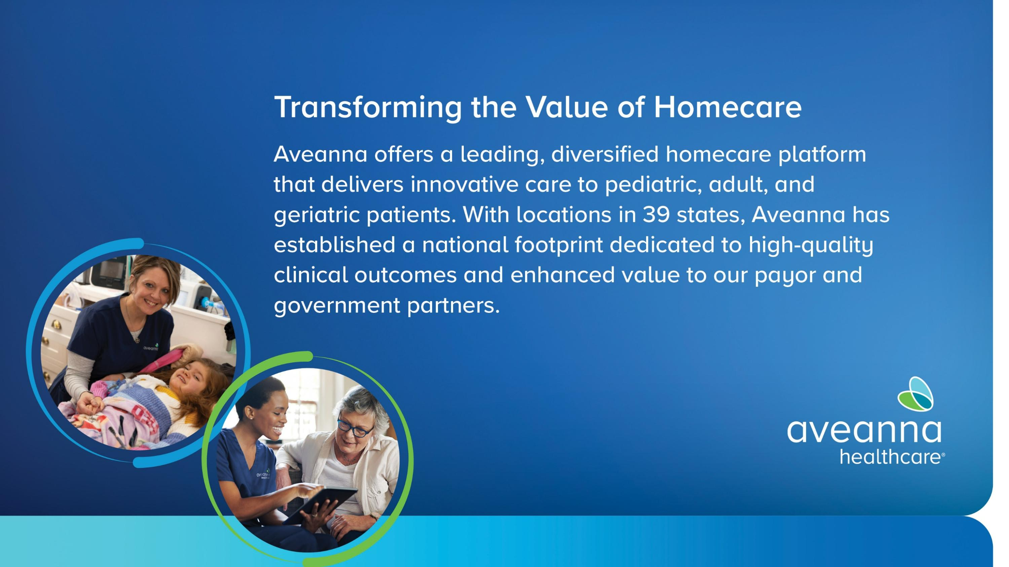

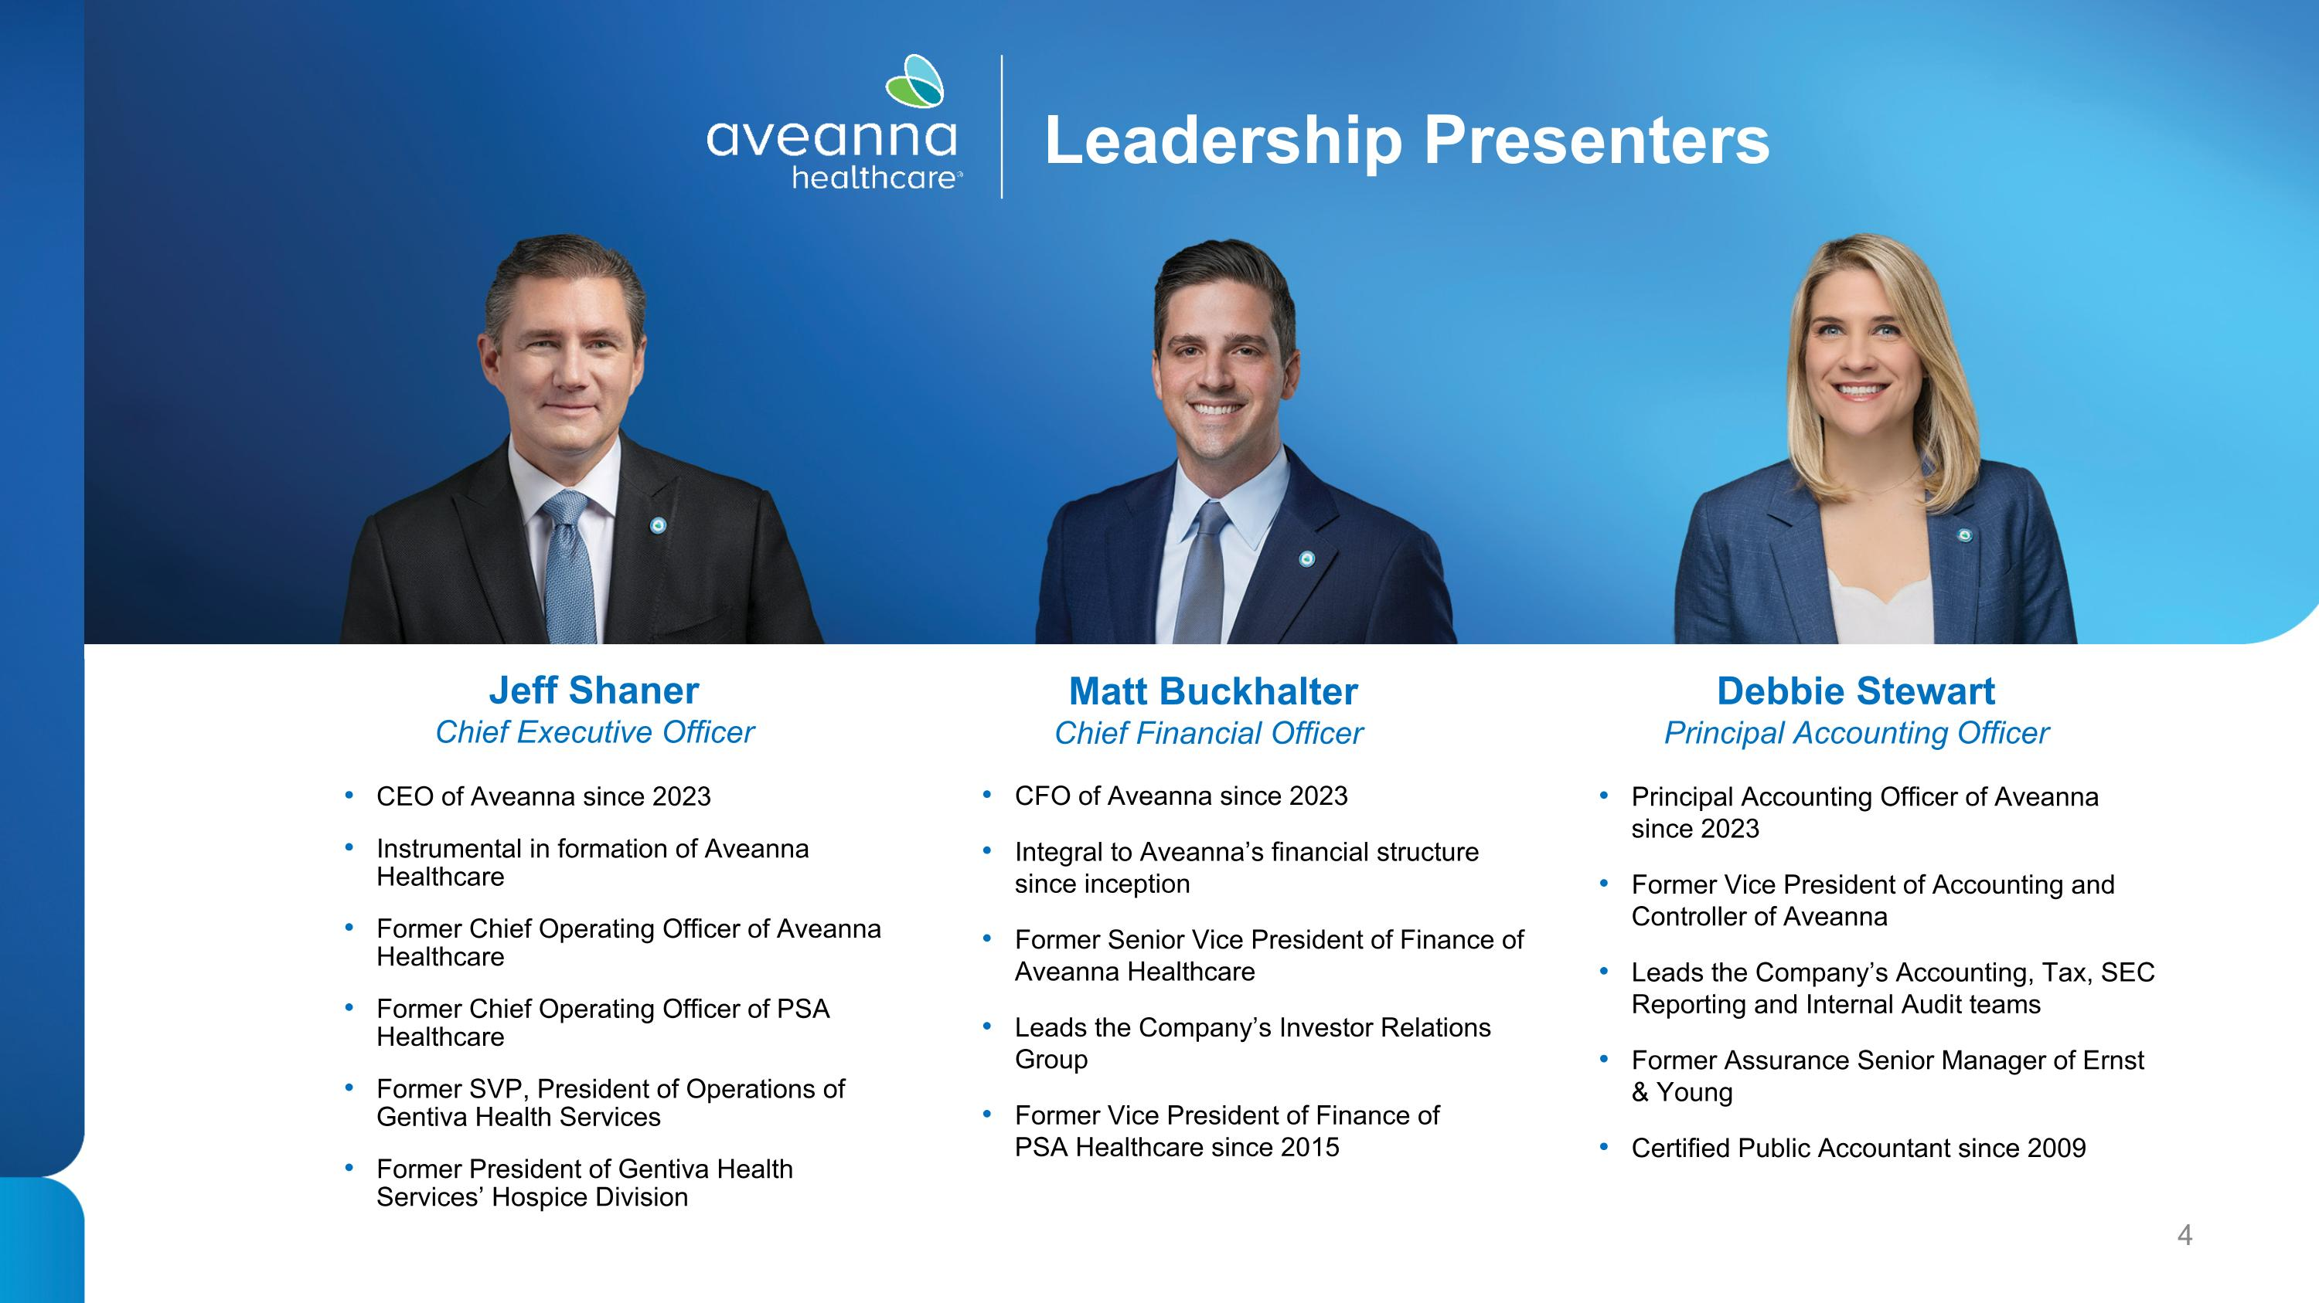
Debbie Stewart?Principal Accounting Officer Jeff Shaner Chief Executive Officer CEO of Aveanna since 2023 Instrumental in formation of Aveanna Healthcare Former Chief Operating Officer of Aveanna Healthcare Former Chief Operating Officer of PSA Healthcare Former SVP, President of Operations of Gentiva Health Services Former President of Gentiva Health ?Services’ Hospice Division CFO of Aveanna since 2023 Integral to Aveanna’s financial structure ?since inception Former Senior Vice President of Finance of Aveanna Healthcare Leads the Company’s Investor Relations Group Former Vice President of Finance of ?PSA Healthcare since 2015 Principal Accounting Officer of Aveanna since 2023 Former Vice President of Accounting and Controller of Aveanna Leads the Company’s Accounting, Tax, SEC Reporting and Internal Audit teams Former Assurance Senior Manager of Ernst & Young Certified Public Accountant since 2009 Matt Buckhalter?Chief Financial Officer Leadership Presenters

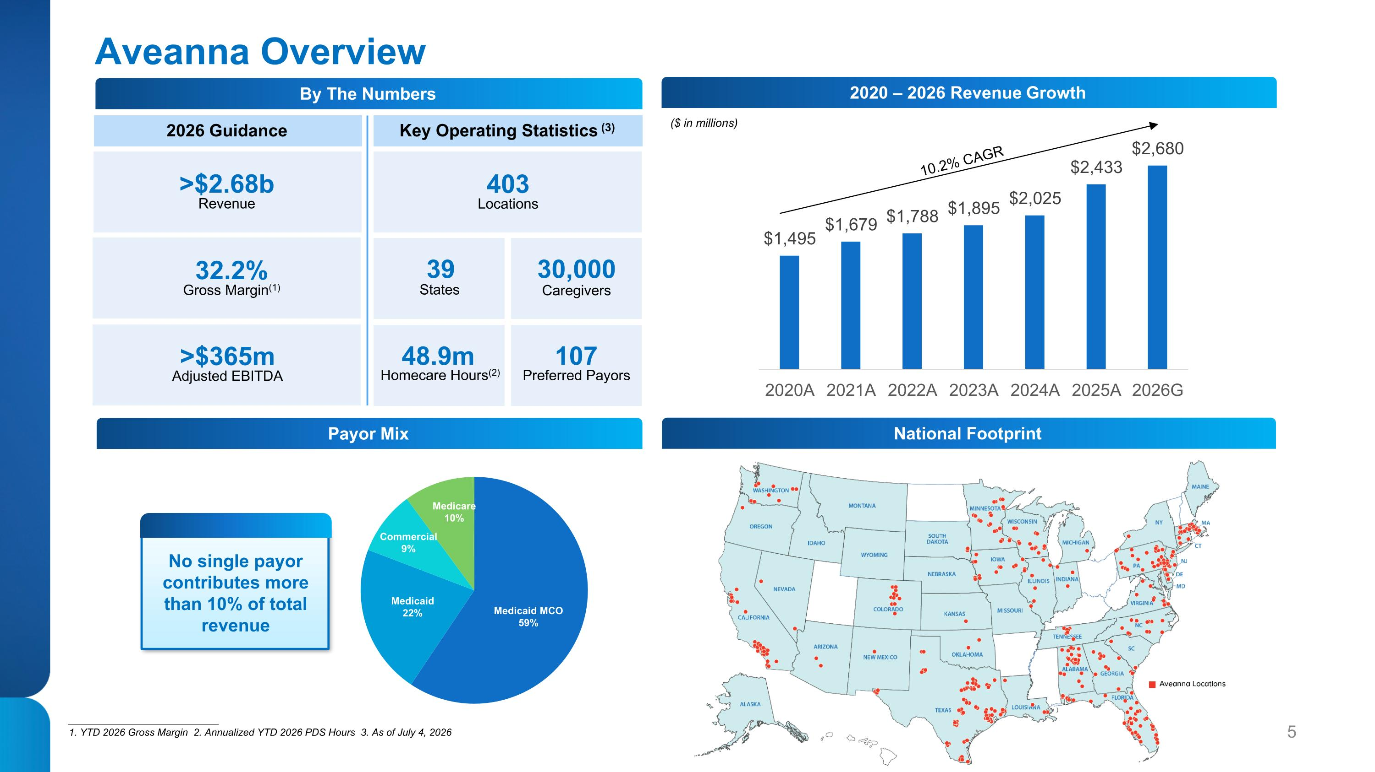
Aveanna Overview 2026 Guidance Key Operating Statistics (3) >$2.68b Revenue 32.2%?Gross Margin(1) >$365m?Adjusted EBITDA 403 ?Locations 39 States 30,000 Caregivers 48.9m Homecare Hours(2) 107 Preferred Payors ___________________________ 1. YTD 2026 Gross Margin 2. Annualized YTD 2026 PDS Hours 3. As of July 4, 2026 ($ in millions) 10.2% CAGR By The Numbers Payor Mix 2020 – 2026 Revenue Growth National Footprint No single payor contributes more than 10% of total revenue

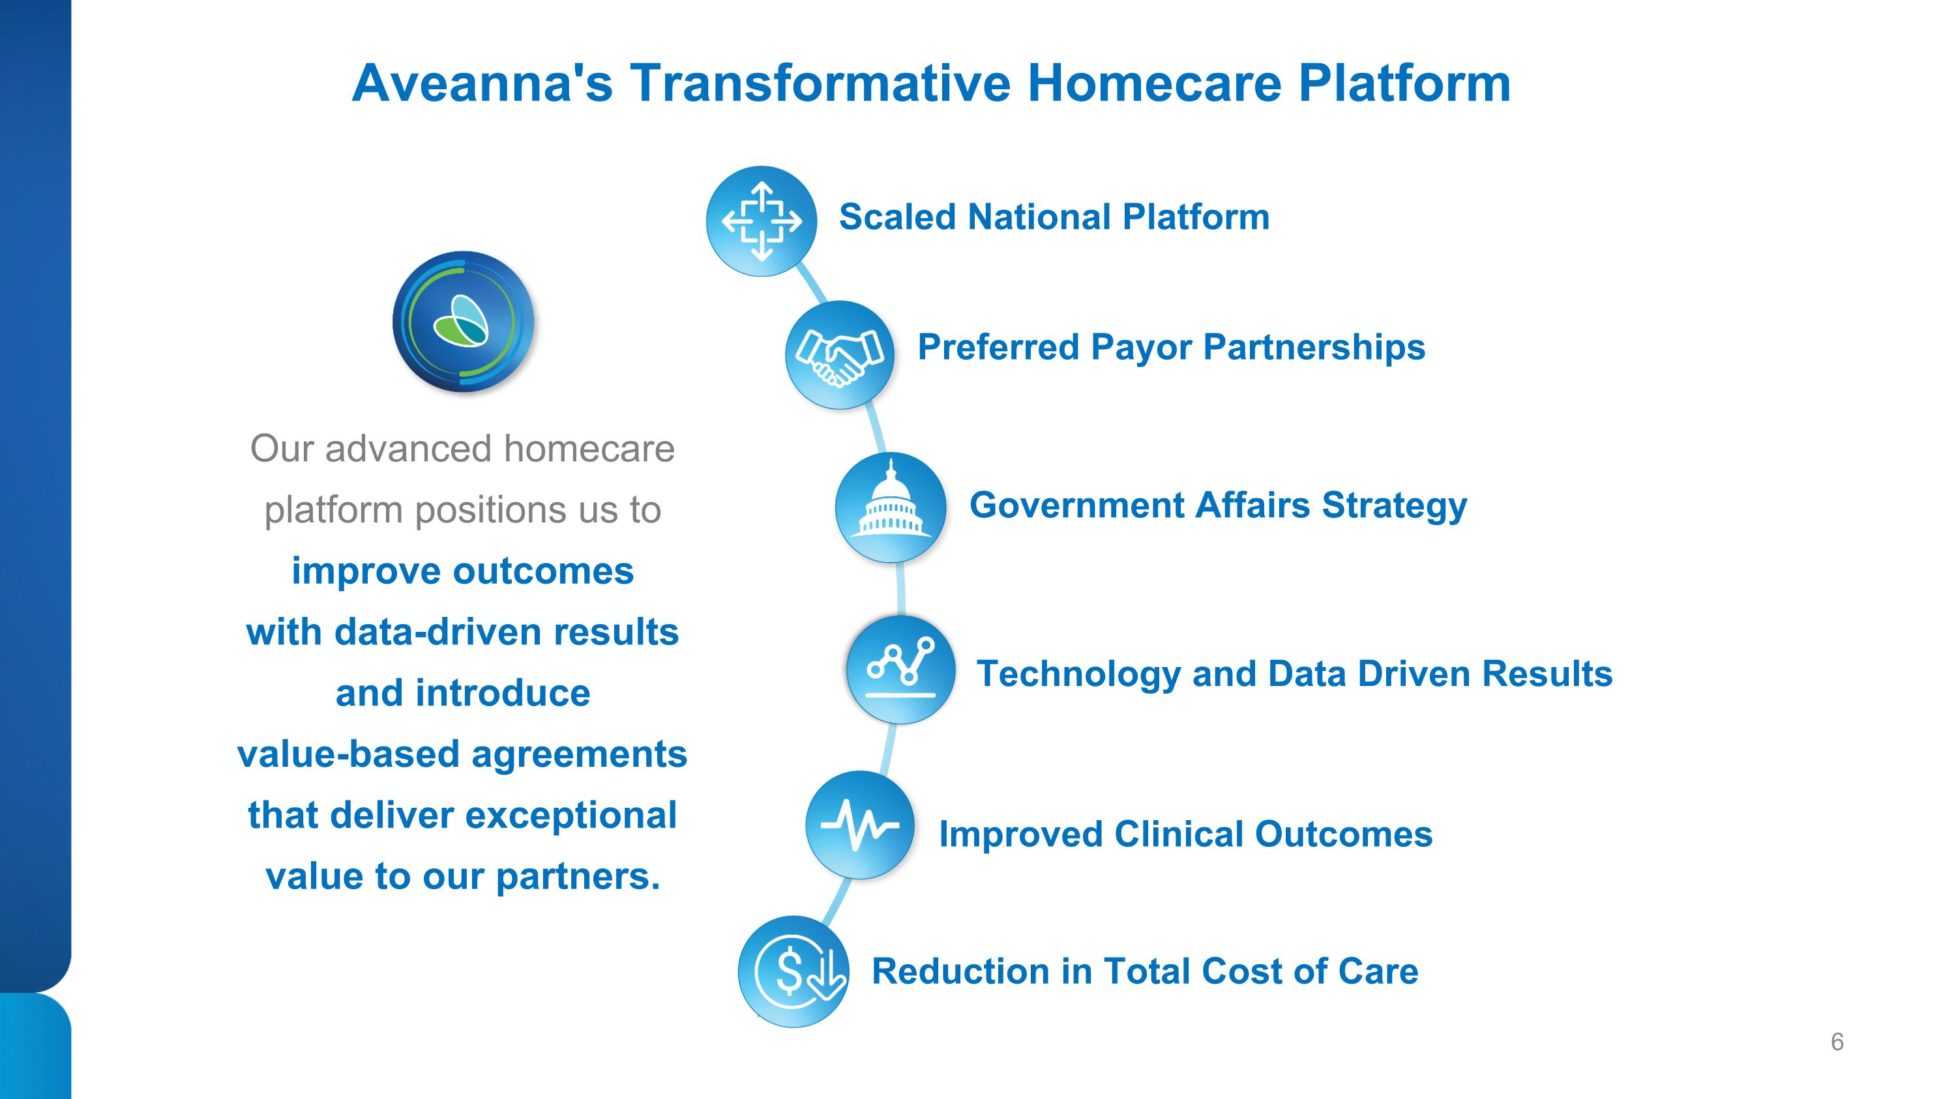
Melia and Mom Heather Valerie Aveanna's Transformative Homecare Platform Preferred Payor Partnerships Government Affairs Strategy Scaled National Platform Technology and Data Driven Results Reduction in Total Cost of Care Our advanced homecare platform positions us to improve outcomes with data-driven results and introduce ?value-based agreements that deliver exceptional value to our partners. Improved Clinical Outcomes

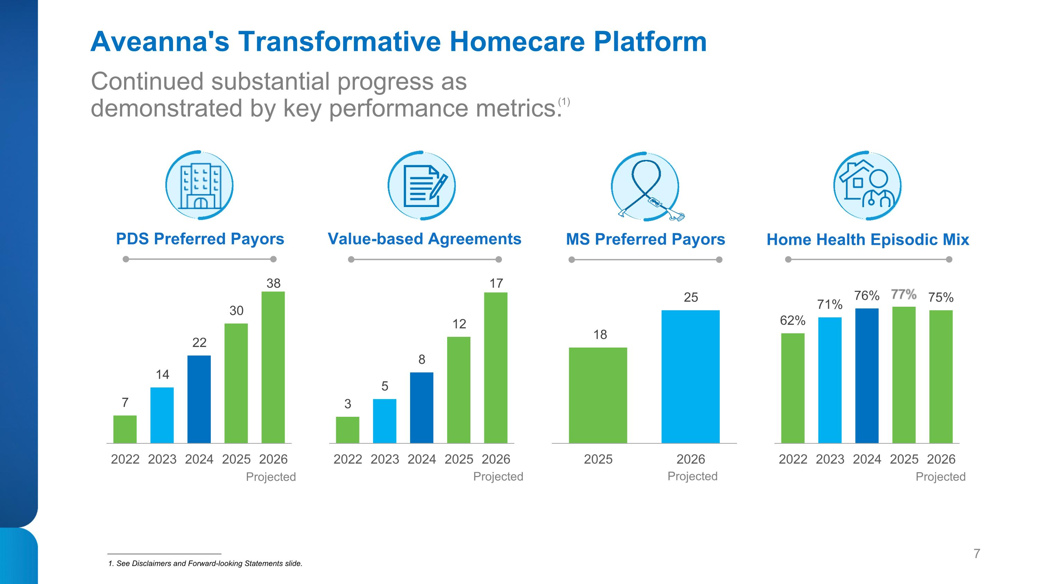
Aveanna's Transformative Homecare Platform PDS Preferred Payors MS Preferred Payors Home Health Episodic Mix Value-based Agreements Continued substantial progress as demonstrated by key performance metrics. (1) ___________________________ 1. See Disclaimers and Forward-looking Statements slide. Projected Projected Projected Projected

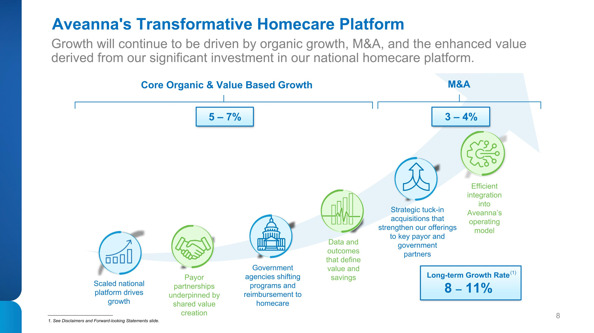
Melia and Mom Heather Valerie Growth will continue to be driven by organic growth, M&A, and the enhanced value derived from our significant investment in our national homecare platform. Aveanna's Transformative Homecare Platform Core Organic & Value Based Growth Scaled national platform drives growth Payor partnerships underpinned by shared value creation Government ?agencies shifting programs and reimbursement to homecare Data and outcomes that define value and savings Strategic tuck-in acquisitions that strengthen our offerings to key payor and government ?partners M&A 5 – 7% 8 – 11% ___________________________ 1. See Disclaimers and Forward-looking Statements slide. Long-term Growth Rate (1) Efficient integration into Aveanna’s operating model 3 – 4%

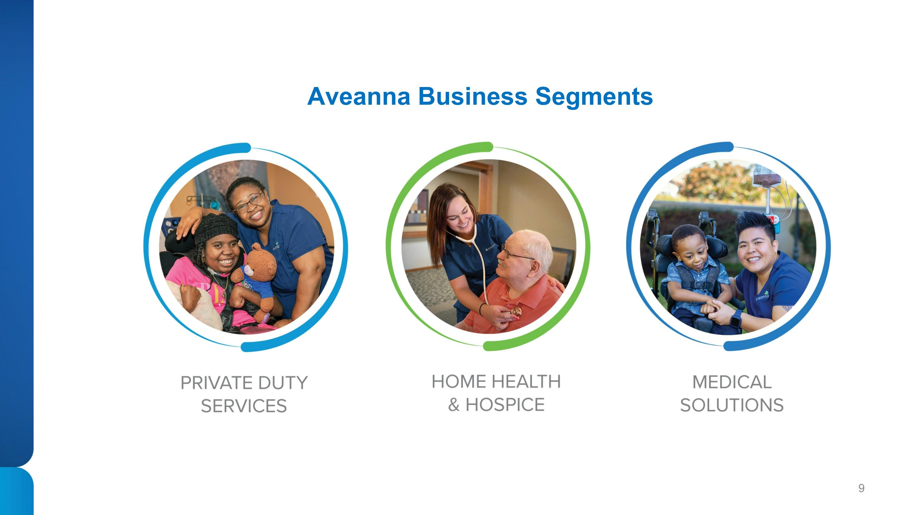
Valerie Melia and Mom Heather Aveanna Business Segments

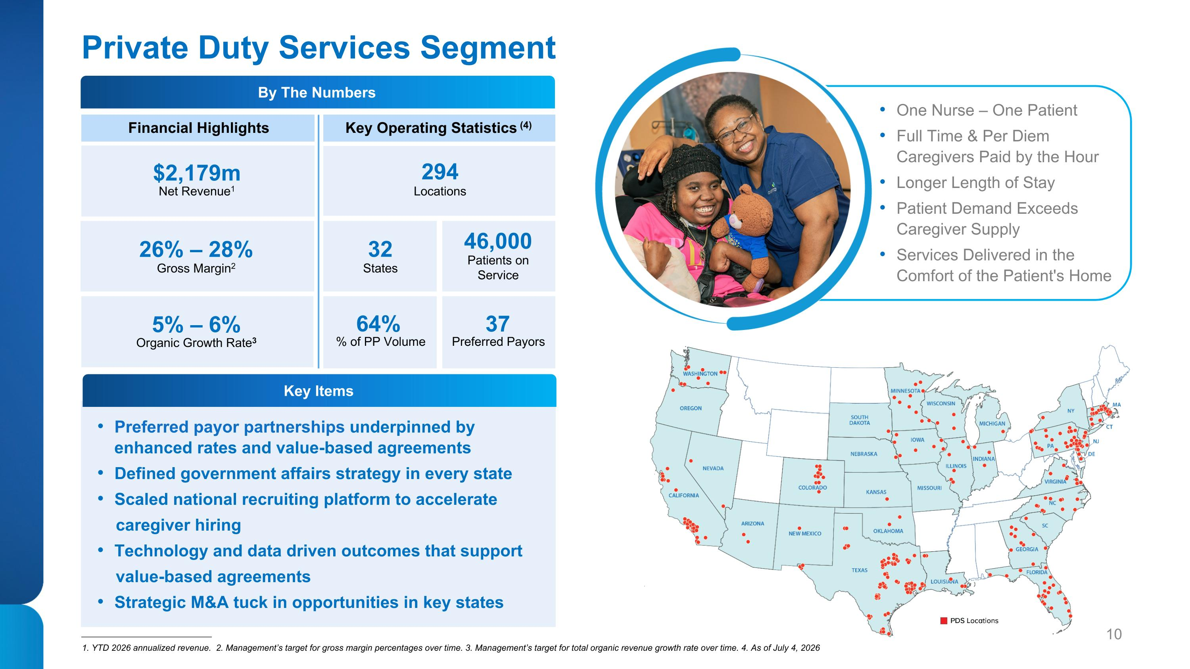
Private Duty Services Segment Financial Highlights Key Operating Statistics (4) $2,179m Net Revenue1 26% – 28%?Gross Margin2 5% – 6%?Organic Growth Rate3 294 Locations 32 States 46,000 Patients on ?Service 64% % of PP Volume Preferred Payors 37 Preferred payor partnerships underpinned by ?enhanced rates and value-based agreements Defined government affairs strategy in every state Scaled national recruiting platform to accelerate caregiver hiring Technology and data driven outcomes that support value-based agreements Strategic M&A tuck in opportunities in key states ___________________________ 1. YTD 2026 annualized revenue. 2. Management’s target for gross margin percentages over time. 3. Management’s target for total organic revenue growth rate over time. 4. As of July 4, 2026 One Nurse – One Patient Full Time & Per Diem Caregivers Paid by the Hour Longer Length of Stay Patient Demand Exceeds Caregiver Supply Services Delivered in the Comfort of the Patient's Home By The Numbers Key Items

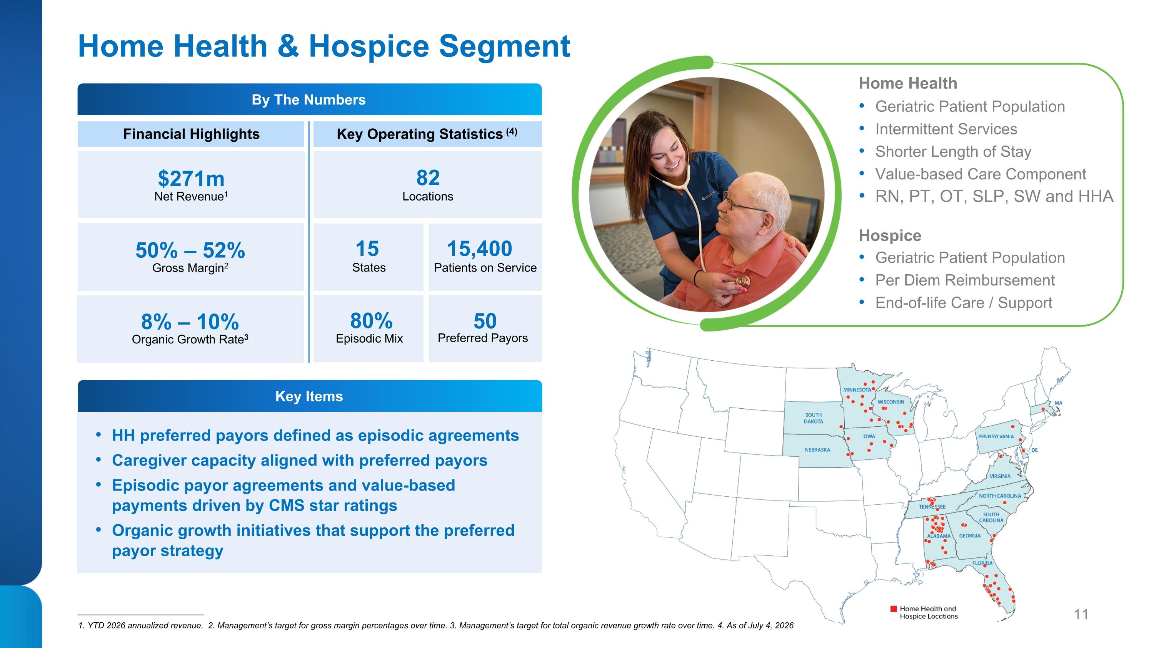
Home Health & Hospice Segment Financial Highlights Key Operating Statistics (4) Locations States Patients on Service Episodic Mix Preferred Payors $271m Net Revenue1 50% – 52%?Gross Margin2 8% – 10%?Organic Growth Rate3 82 15 15,400 50 Home Health Geriatric Patient Population Intermittent Services Shorter Length of Stay Value-based Care Component RN, PT, OT, SLP, SW and HHA Hospice Geriatric Patient Population Per Diem Reimbursement End-of-life Care / Support ___________________________ 1. YTD 2026 annualized revenue. 2. Management’s target for gross margin percentages over time. 3. Management’s target for total organic revenue growth rate over time. 4. As of July 4, 2026 80% HH preferred payors defined as episodic agreements Caregiver capacity aligned with preferred payors Episodic payor agreements and value-based payments driven by CMS star ratings Organic growth initiatives that support the preferred payor strategy By The Numbers Key Items

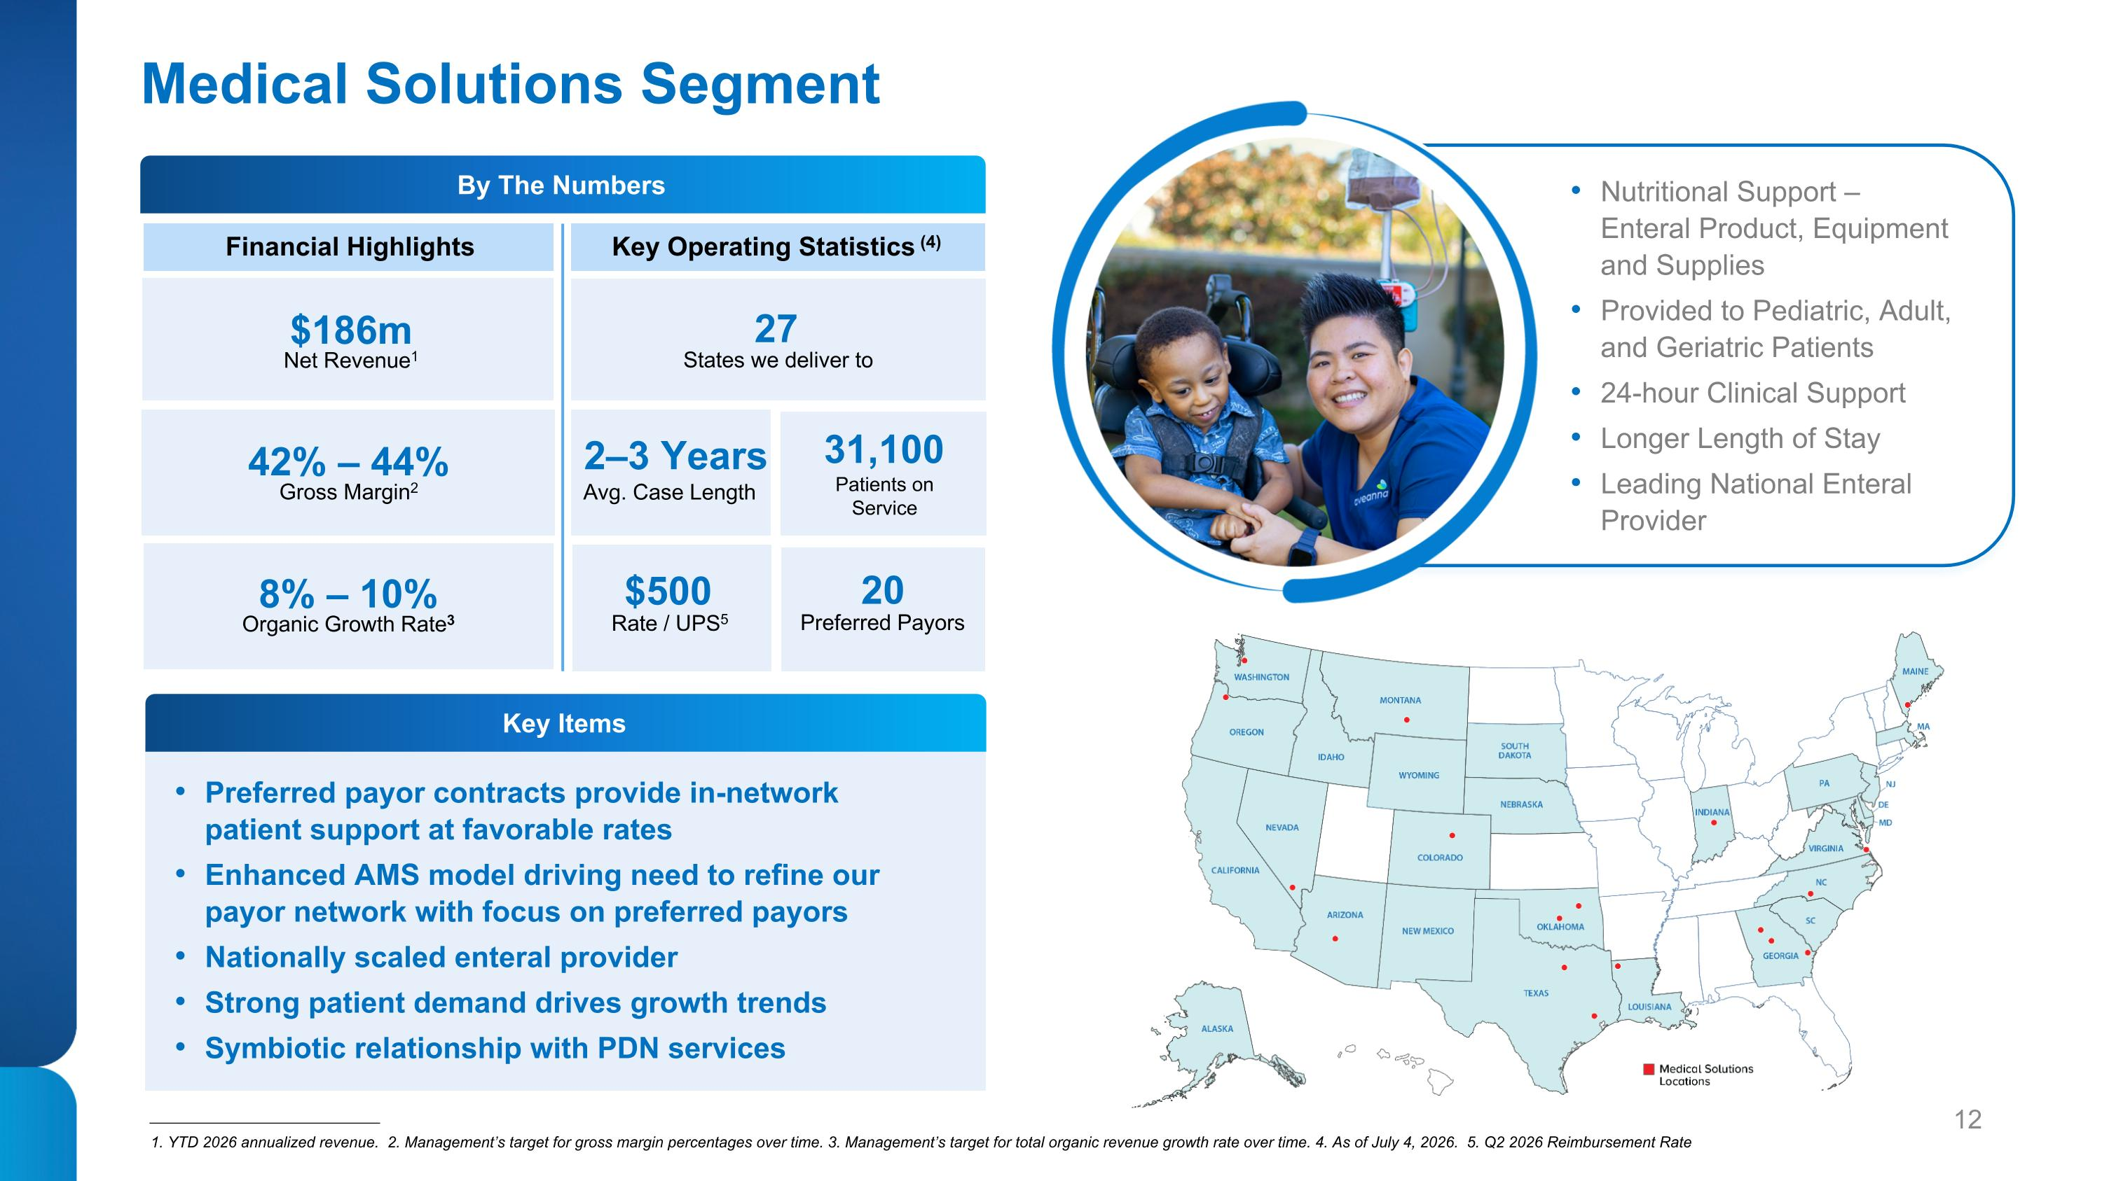
Medical Solutions Segment Financial Highlights Key Operating Statistics (4) States we deliver to Patients on ?Service Preferred Payors $186m Net Revenue1 42% – 44%?Gross Margin2 8% – 10%?Organic Growth Rate3 27 31,100 20 Nutritional Support – ?Enteral Product, Equipment and Supplies Provided to Pediatric, Adult, and Geriatric Patients 24-hour Clinical Support Longer Length of Stay Leading National Enteral Provider ___________________________ 1. YTD 2026 annualized revenue. 2. Management’s target for gross margin percentages over time. 3. Management’s target for total organic revenue growth rate over time. 4. As of July 4, 2026. 5. Q2 2026 Reimbursement Rate Preferred payor contracts provide in-network patient support at favorable rates Enhanced AMS model driving need to refine our ?payor network with focus on preferred payors Nationally scaled enteral provider Strong patient demand drives growth trends Symbiotic relationship with PDN services Key Items By The Numbers 2–3 Years Avg. Case Length Rate / UPS5 $500

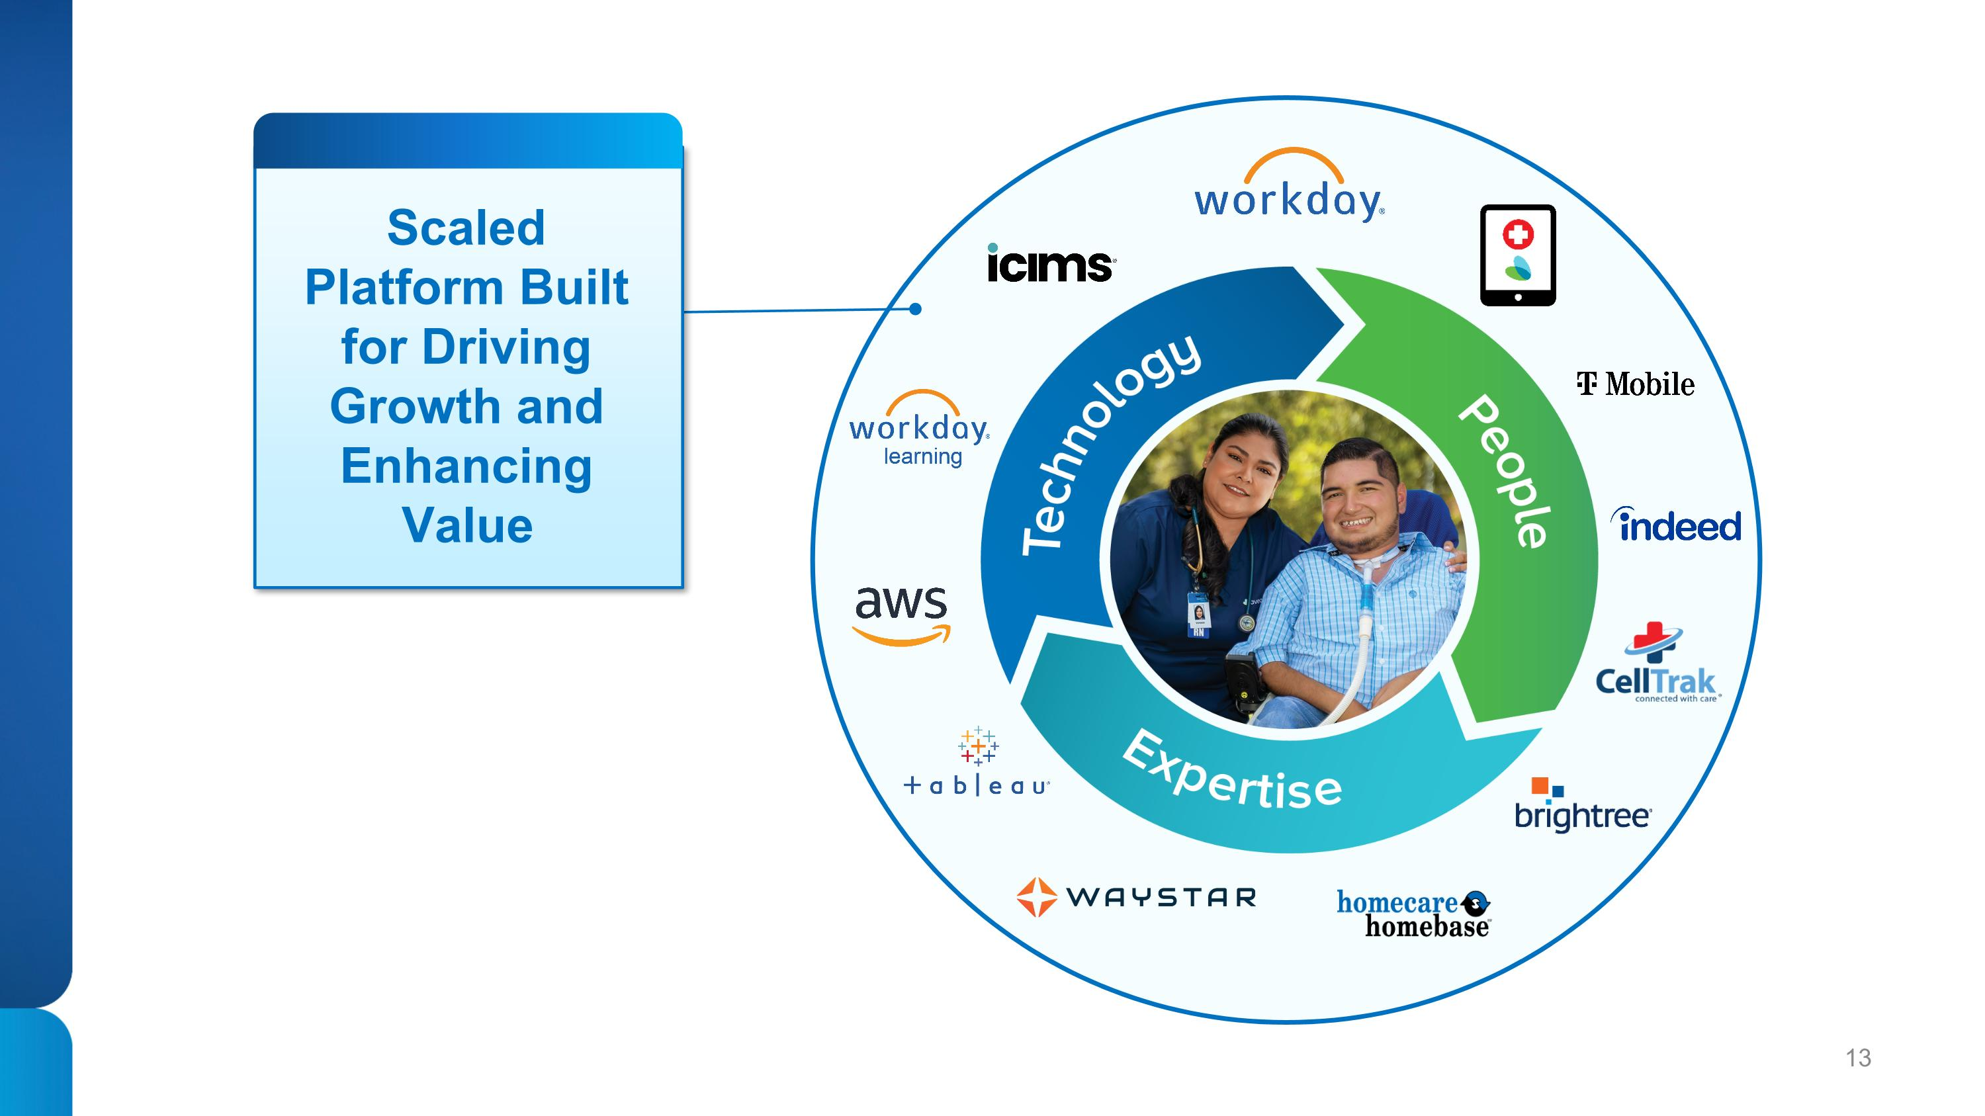
Scaled Platform Built for Driving Growth and Enhancing Value

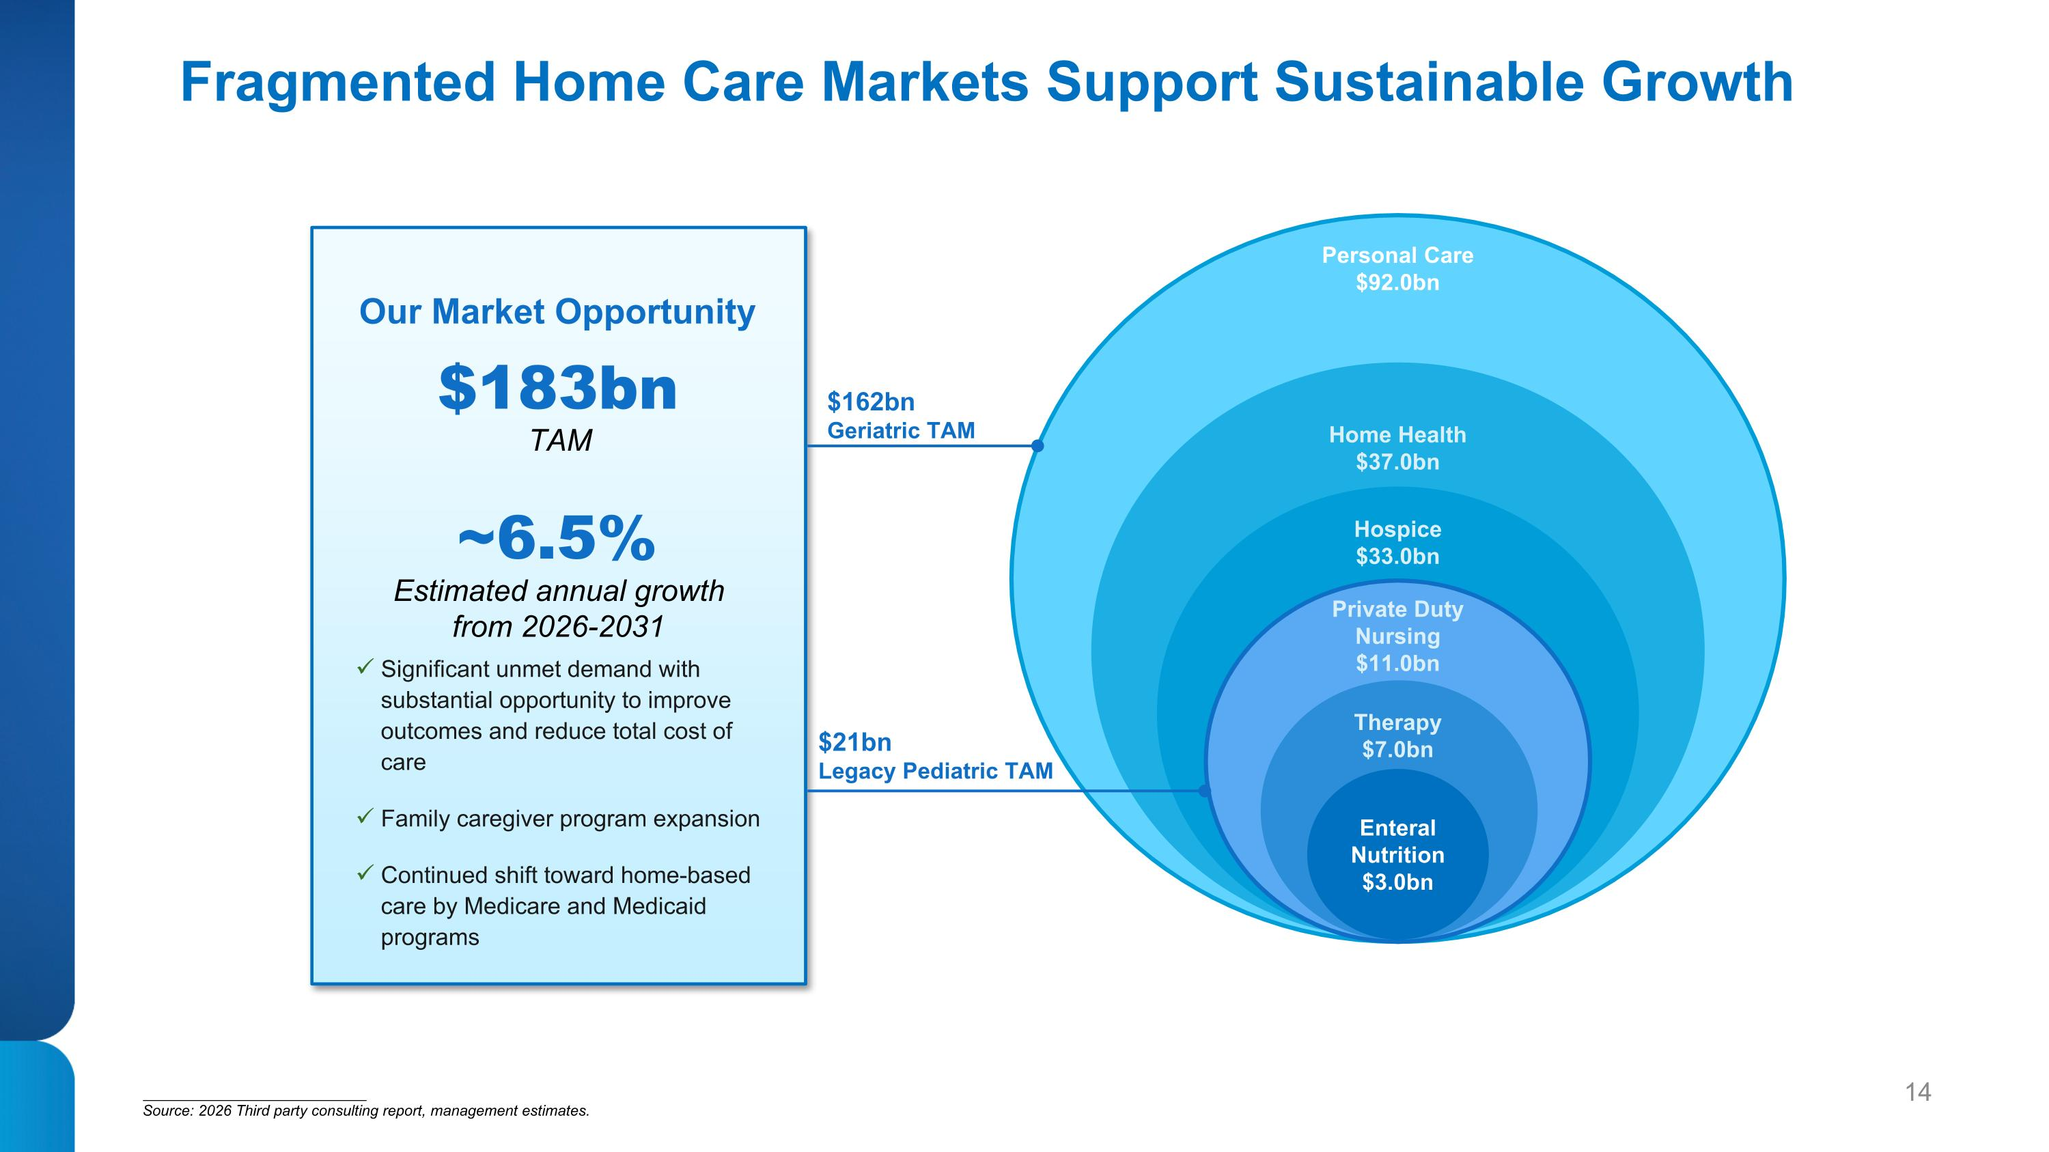
Fragmented Home Care Markets Support Sustainable Growth $21bn ?Legacy Pediatric TAM Hospice $33.0bn Enteral Nutrition $3.0bn Therapy $7.0bn Private Duty ?Nursing $11.0bn Home Health $37.0bn TAM Estimated annual growth from 2026-2031 $183bn ~6.5% Significant unmet demand with substantial opportunity to improve outcomes and reduce total cost of care Family caregiver program expansion Continued shift toward home-based care by Medicare and Medicaid programs Our Market Opportunity Personal Care $92.0bn ___________________________ Source: 2026 Third party consulting report, management estimates. $162bn ?Geriatric TAM

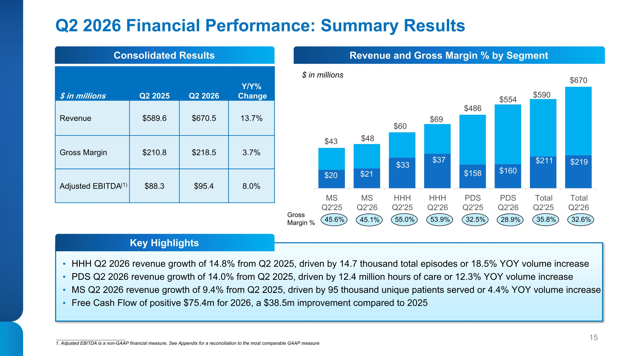
Q2 2026 Financial Performance: Summary Results HHH Q2 2026 revenue growth of 14.8% from Q2 2025, driven by 14.7 thousand total episodes or 18.5% YOY volume increase PDS Q2 2026 revenue growth of 14.0% from Q2 2025, driven by 12.4 million hours of care or 12.3% YOY volume increase MS Q2 2026 revenue growth of 9.4% from Q2 2025, driven by 95 thousand unique patients served or 4.4% YOY volume increase Free Cash Flow of positive $75.4m for 2026, a $38.5m improvement compared to 2025 $ in millions Q2 2025 Q2 2026 Y/Y%? Change Revenue $589.6 $670.5 13.7% Gross Margin $210.8 $218.5 3.7% Adjusted EBITDA(1) $88.3 $95.4 8.0% 35.8% 32.6% 32.5% 28.9% 55.0% 53.9% 45.6% 45.1% Gross Margin % ___________________________ 1. Adjusted EBITDA is a non-GAAP financial measure. See Appendix for a reconciliation to the most comparable GAAP measure Consolidated Results Key Highlights Revenue and Gross Margin % by Segment $ in millions

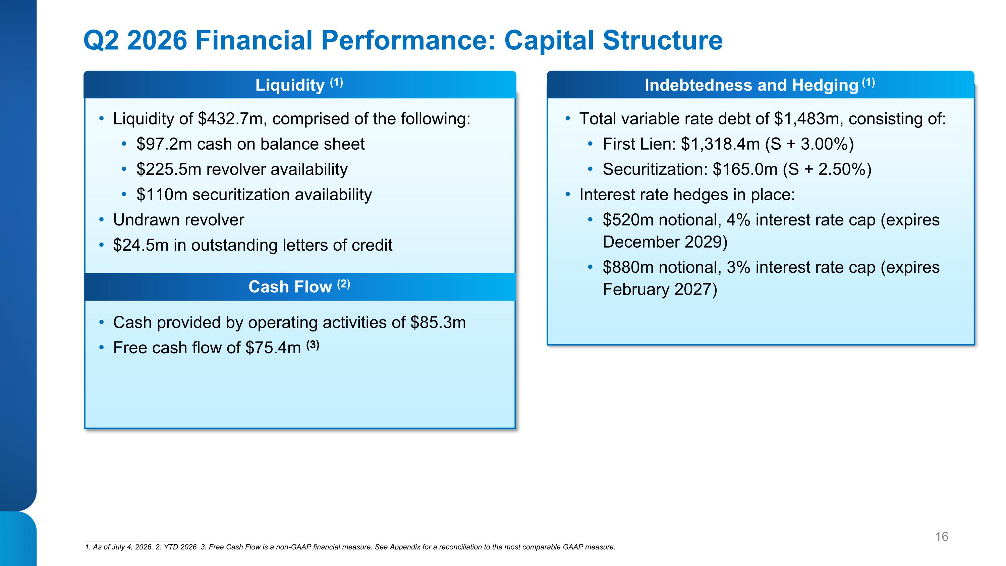
Q2 2026 Financial Performance: Capital Structure Liquidity of $432.7m, comprised of the following: $97.2m cash on balance sheet $225.5m revolver availability $110m securitization availability Undrawn revolver $24.5m in outstanding letters of credit Total variable rate debt of $1,483m, consisting of: First Lien: $1,318.4m (S + 3.00%) Securitization: $165.0m (S + 2.50%) Interest rate hedges in place: $520m notional, 4% interest rate cap (expires ?December 2029) $880m notional, 3% interest rate cap (expires February 2027) ___________________________ 1. As of July 4, 2026. 2. YTD 2026 3. Free Cash Flow is a non-GAAP financial measure. See Appendix for a reconciliation to the most comparable GAAP measure. Cash provided by operating activities of $85.3m Free cash flow of $75.4m (3) Liquidity (1) Cash Flow (2) Indebtedness and Hedging (1)

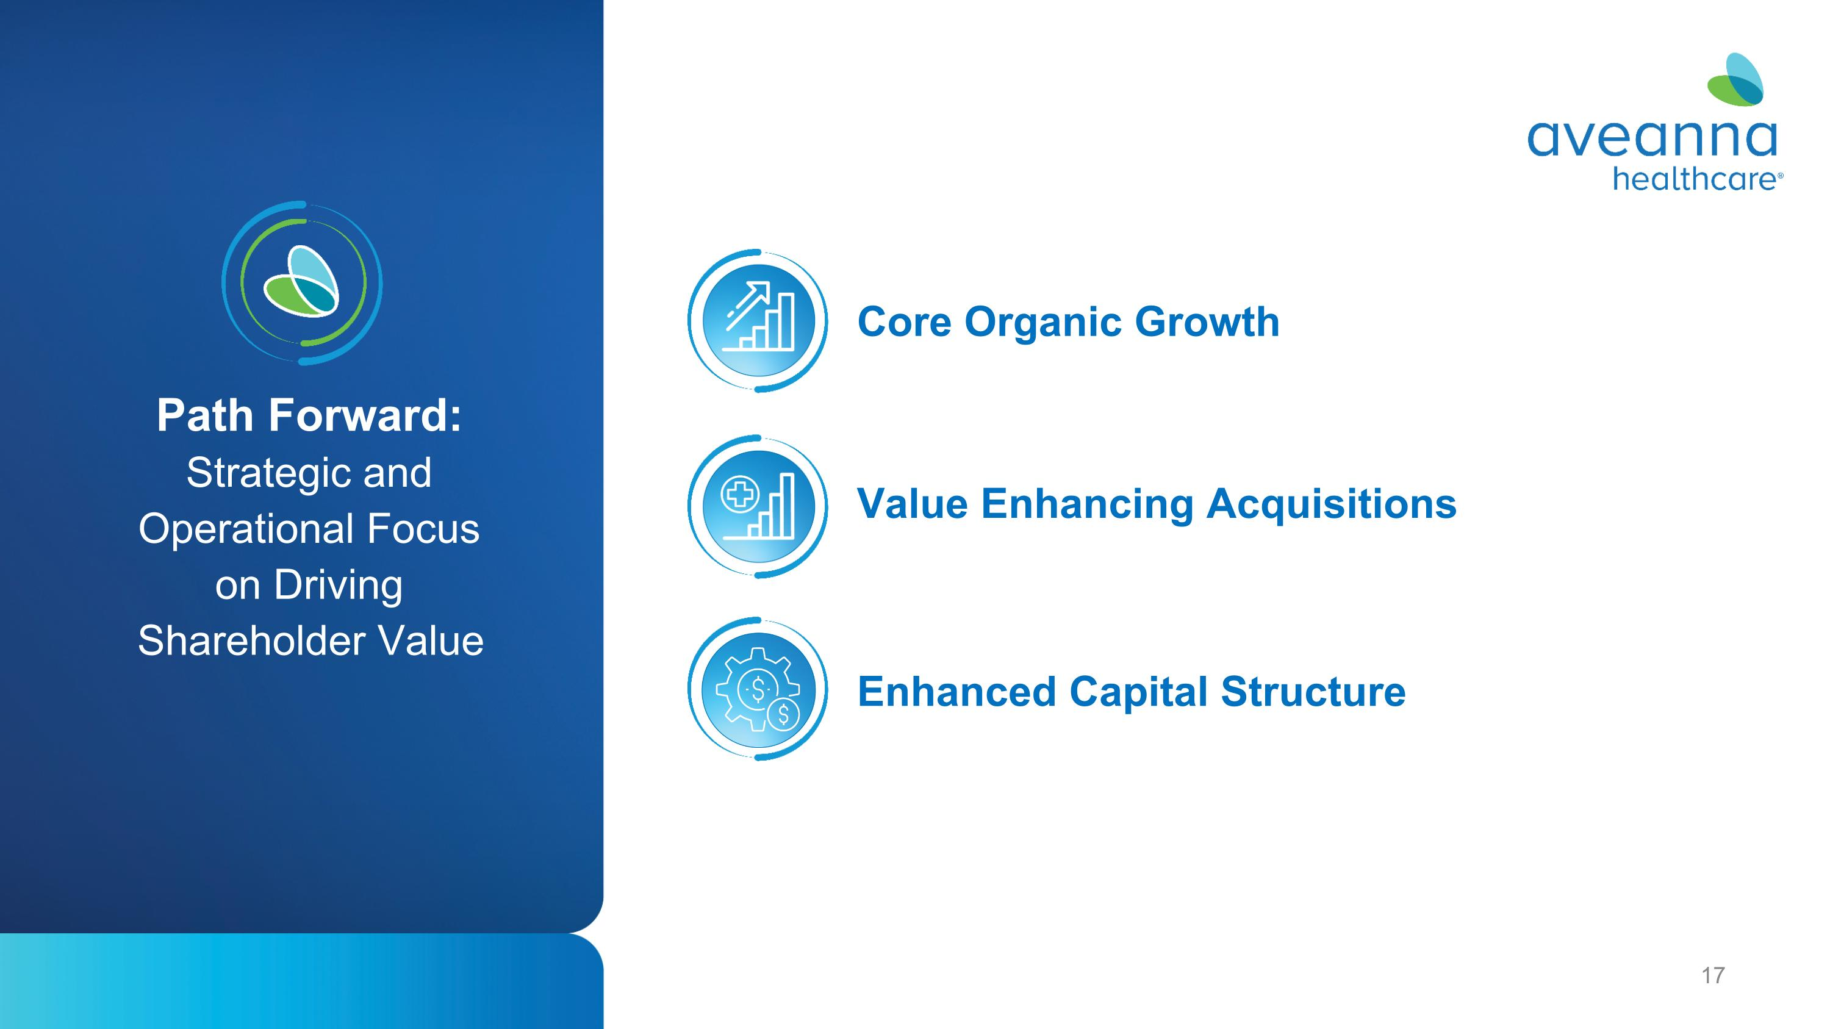
Path Forward:?Strategic and Operational Focus ?on Driving Shareholder Value Value Enhancing Acquisitions Core Organic Growth Enhanced Capital Structure


Appendix

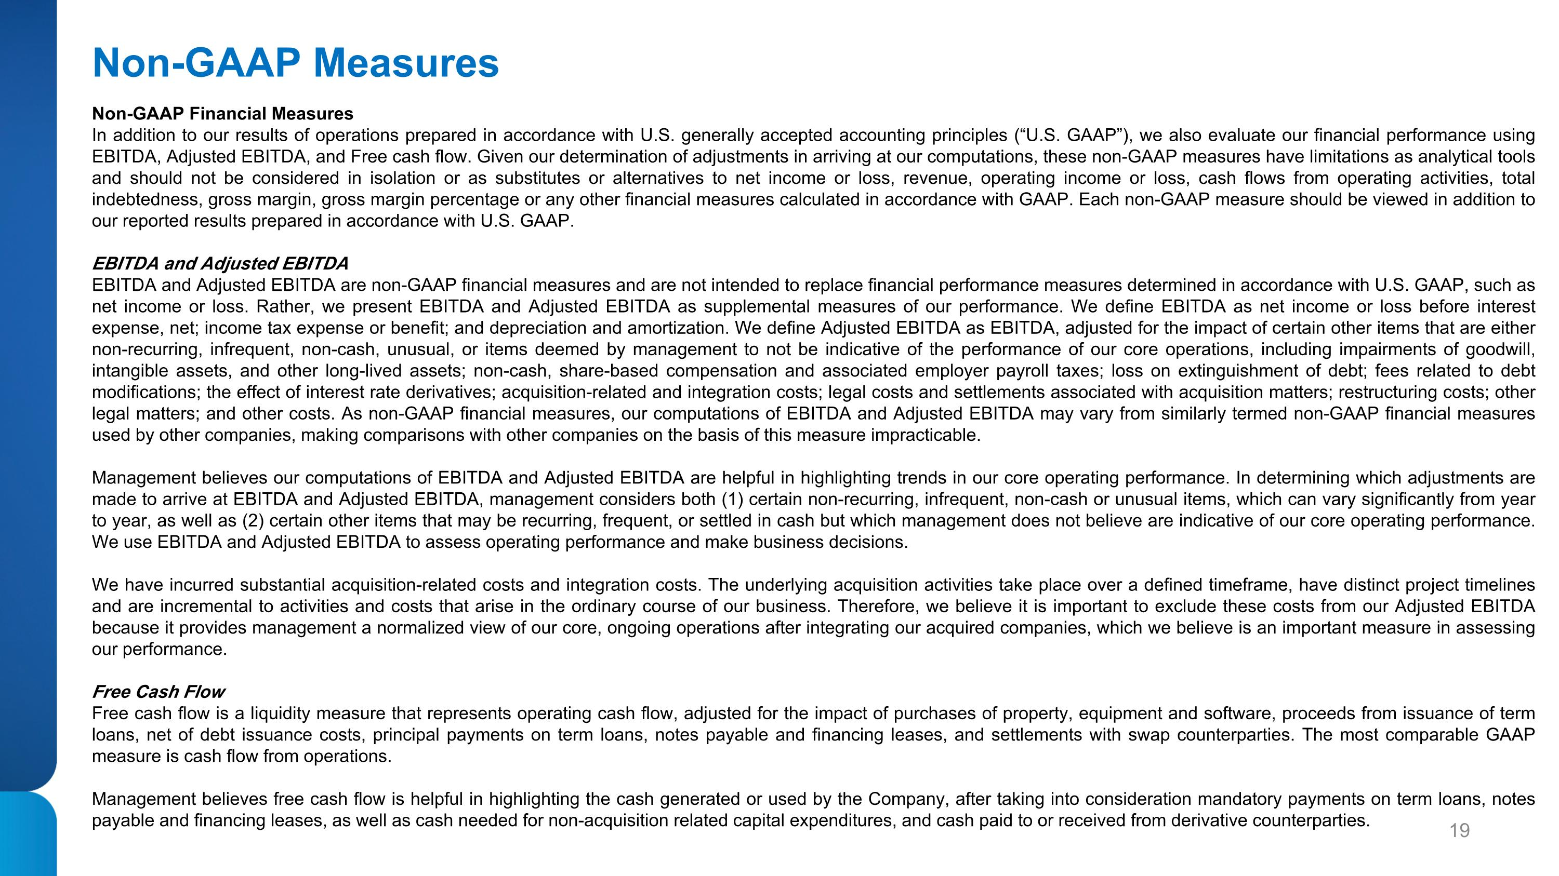
Non-GAAP Measures Non-GAAP Financial Measures In addition to our results of operations prepared in accordance with U.S. generally accepted accounting principles (“U.S. GAAP”), we also evaluate our financial performance using EBITDA, Adjusted EBITDA, and Free cash flow. Given our determination of adjustments in arriving at our computations, these non-GAAP measures have limitations as analytical tools and should not be considered in isolation or as substitutes or alternatives to net income or loss, revenue, operating income or loss, cash flows from operating activities, total indebtedness, gross margin, gross margin percentage or any other financial measures calculated in accordance with GAAP. Each non-GAAP measure should be viewed in addition to our reported results prepared in accordance with U.S. GAAP. EBITDA and Adjusted EBITDA EBITDA and Adjusted EBITDA are non-GAAP financial measures and are not intended to replace financial performance measures determined in accordance with U.S. GAAP, such as net income or loss. Rather, we present EBITDA and Adjusted EBITDA as supplemental measures of our performance. We define EBITDA as net income or loss before interest expense, net; income tax expense or benefit; and depreciation and amortization. We define Adjusted EBITDA as EBITDA, adjusted for the impact of certain other items that are either non-recurring, infrequent, non-cash, unusual, or items deemed by management to not be indicative of the performance of our core operations, including impairments of goodwill, intangible assets, and other long-lived assets; non-cash, share-based compensation and associated employer payroll taxes; loss on extinguishment of debt; fees related to debt modifications; the effect of interest rate derivatives; acquisition-related and integration costs; legal costs and settlements associated with acquisition matters; restructuring costs; other legal matters; and other costs. As non-GAAP financial measures, our computations of EBITDA and Adjusted EBITDA may vary from similarly termed non-GAAP financial measures used by other companies, making comparisons with other companies on the basis of this measure impracticable. Management believes our computations of EBITDA and Adjusted EBITDA are helpful in highlighting trends in our core operating performance. In determining which adjustments are made to arrive at EBITDA and Adjusted EBITDA, management considers both (1) certain non-recurring, infrequent, non-cash or unusual items, which can vary significantly from year to year, as well as (2) certain other items that may be recurring, frequent, or settled in cash but which management does not believe are indicative of our core operating performance. We use EBITDA and Adjusted EBITDA to assess operating performance and make business decisions. We have incurred substantial acquisition-related costs and integration costs. The underlying acquisition activities take place over a defined timeframe, have distinct project timelines and are incremental to activities and costs that arise in the ordinary course of our business. Therefore, we believe it is important to exclude these costs from our Adjusted EBITDA because it provides management a normalized view of our core, ongoing operations after integrating our acquired companies, which we believe is an important measure in assessing our performance. Free Cash Flow Free cash flow is a liquidity measure that represents operating cash flow, adjusted for the impact of purchases of property, equipment and software, proceeds from issuance of term loans, net of debt issuance costs, principal payments on term loans, notes payable and financing leases, and settlements with swap counterparties. The most comparable GAAP measure is cash flow from operations. Management believes free cash flow is helpful in highlighting the cash generated or used by the Company, after taking into consideration mandatory payments on term loans, notes payable and financing leases, as well as cash needed for non-acquisition related capital expenditures, and cash paid to or received from derivative counterparties. ﻿

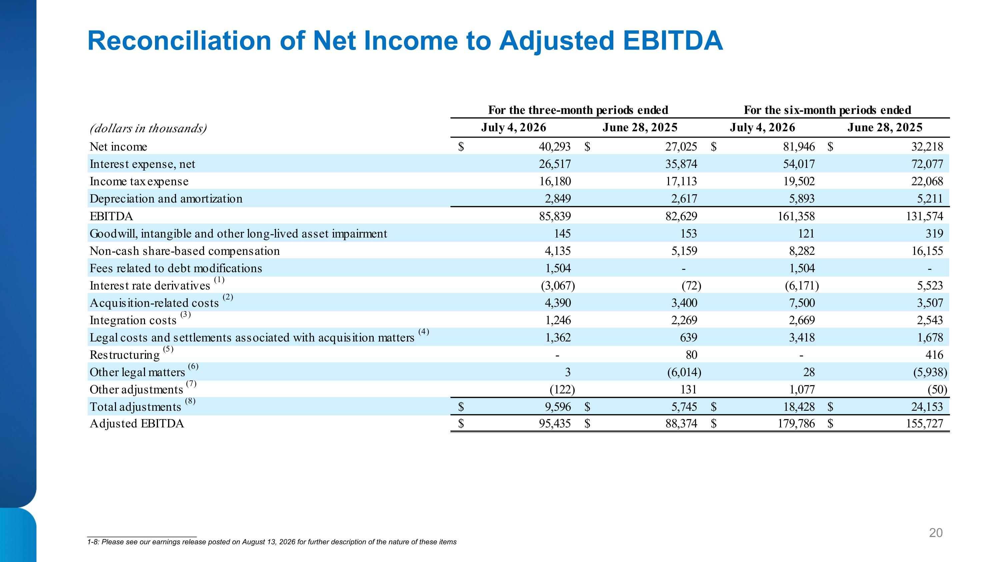
Reconciliation of Net Income to Adjusted EBITDA ___________________________ 1-8: Please see our earnings release posted on August 13, 2026 for further description of the nature of these items

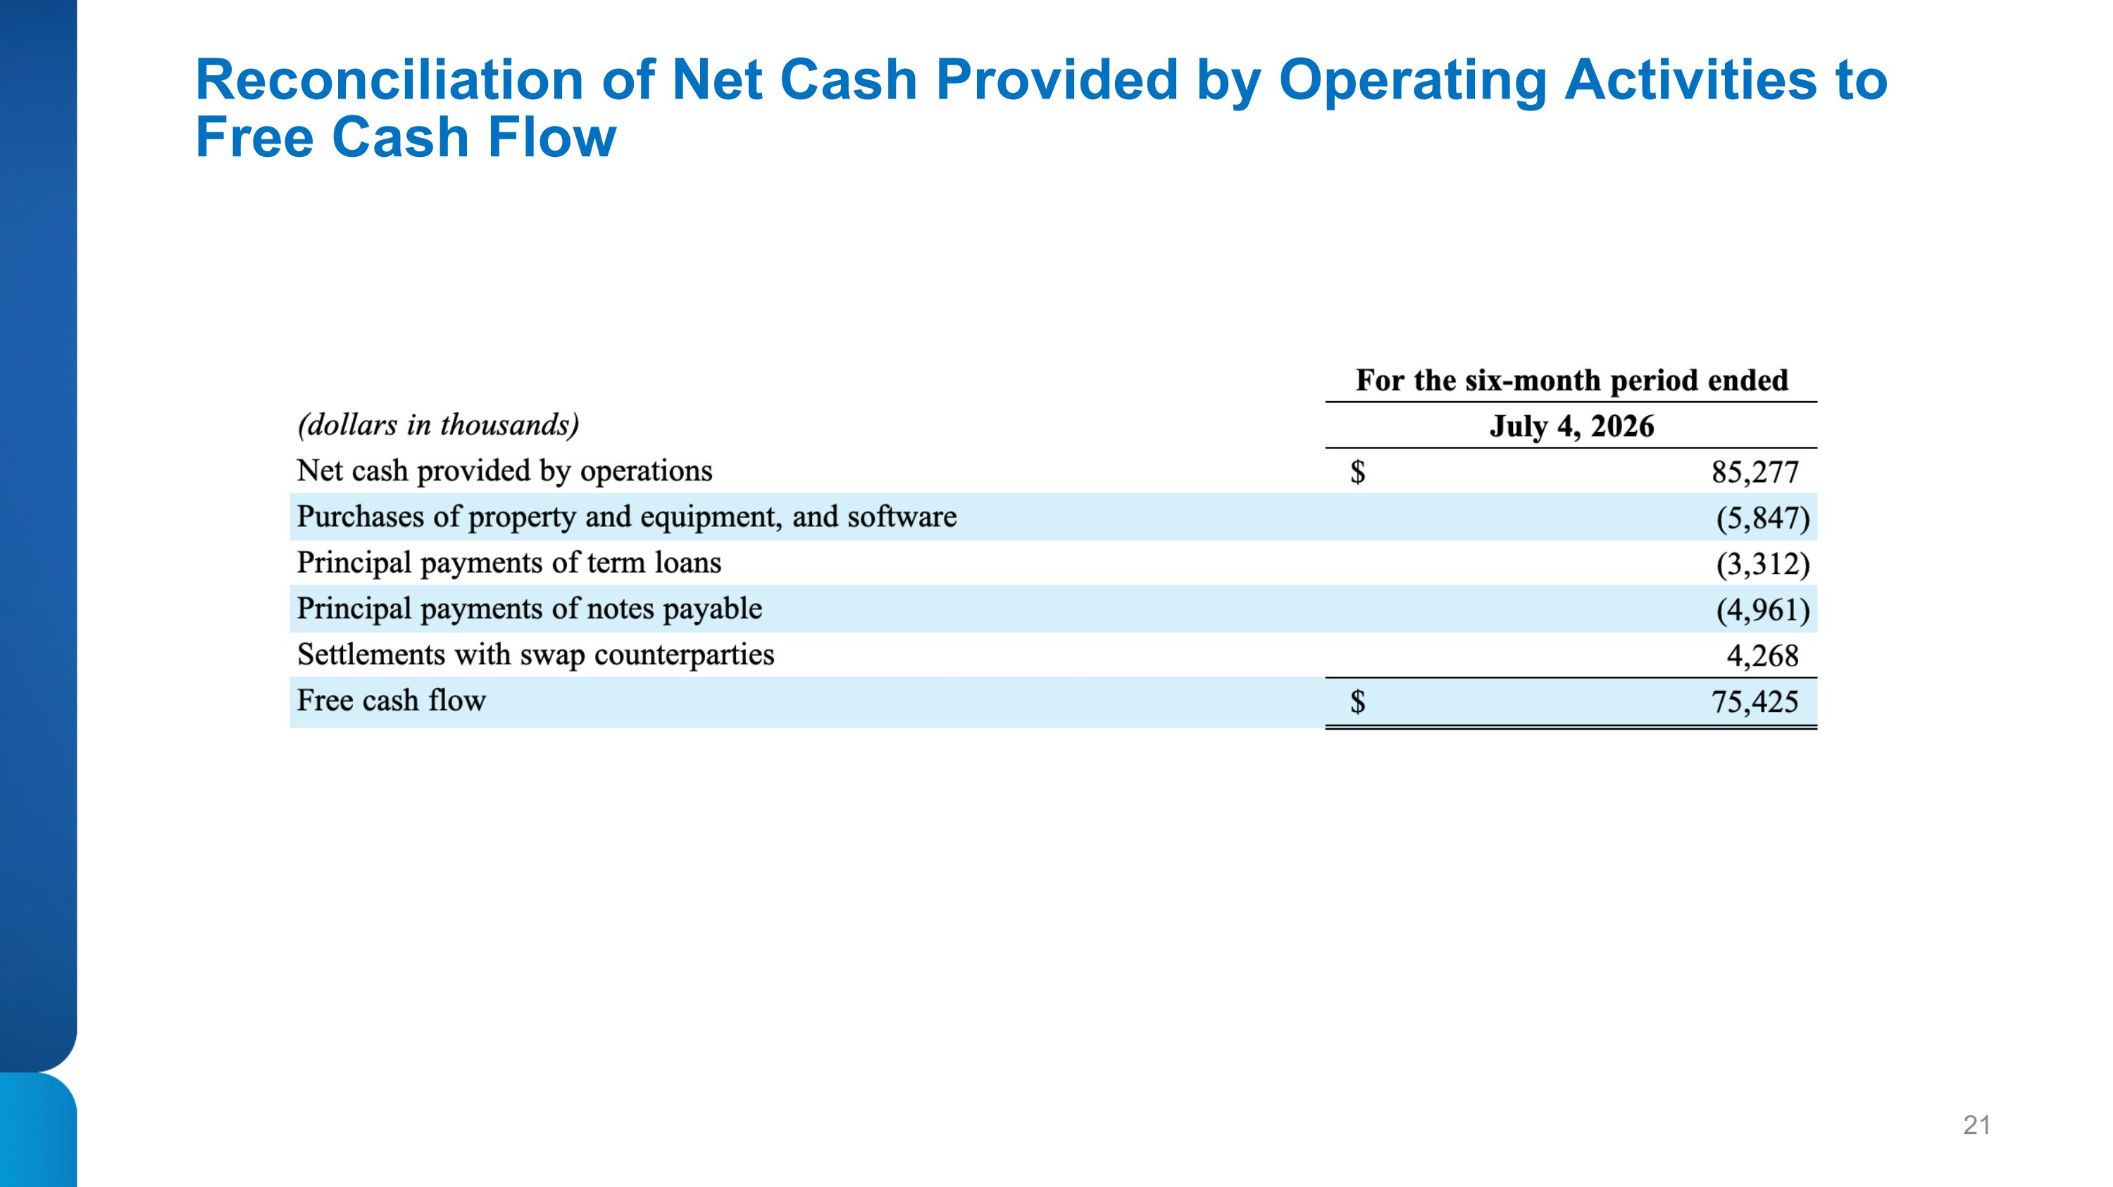
Reconciliation of Net Cash Provided by Operating Activities to Free Cash Flow

